TRANSFORMING YOUR LOGO INTO A PLANOMETRIC SYSTEM USING PHOTOSHOP

Example of original logo shown below.

Set up a new photoshop blank page (A4 size should work) and copy your logo onto this.
Select the logo layer and follow these steps: EDIT TRANSFORM PERSPECTIVE
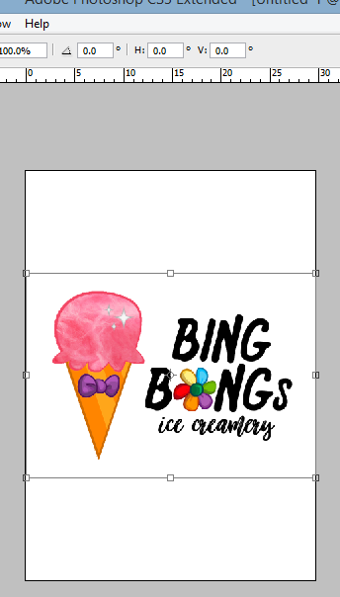
Make sure that the top of your screen looks like this and type
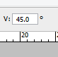
45 into the v: section.

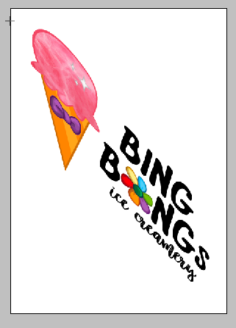

Final result should look like this.

Save and print and use in your icecream shop

